An Intelligent AI-Driven System for Student Mental Health Assessment and Early Risk Detection

Rithikka J
Department of Artificial Intelligence and Data Science
Chennai Institute of Technology (An autonomous Institution)
Chennai, India rithikkaj.aids2022@citchennai.net

Abstract - One of the biggest reasons for the increased dissatisfaction and feelings of being stressed, anxious, or depressed is the combination of school requirements, social life, and the ever-changing schedules of individual daily lives. Yet, the assistance, when provided, remains extremely delayed, scattered, and inaccessible when really required. Today, a new strategy tries to redesign the situation through the application of "smart technology" to identify instances of risk much earlier. Usually, when a student tries to respond to personal questions, the rules provided within the technology identify hidden signs other people might overlook, demonstrating the changes in his or her emotions over a period of time. By categorizing these signs, the rules identify the category to which these changes are likely to belong, based on patterns of behaviour. Its uniqueness, when viewed, remains the stealthy manner in which the entire analysis unfolds behind the student’s routine input, safely provided within a specially designated space, providing instantaneous outcomes, customized answers, one- size-fits-all suggestions – all the while keeping the various details secured within the site itself.From there, regular check- ins continue to pile up in an organized fashion. This means that if well-being is changing, you can see that over time. Tests are conducted against sample student data, where this approach proves more successful at catching issues before they develop than previous methods. Past approaches would see students waiting for intervention, whereas this relies on intervention that’s tailored to each student to bridge the gap.

Keywords - Student Mental Health, AI-Driven Assessment, Rule-Based Decision System, Early Risk Detection, Secure Web-Based Application, Mental Health Screening, Preventive Mental Healthcare.

- INTRODUCTION

With regards to children, common issues ranging from stress, anxiety, and depression are now on the rise due to pressures at school, peer interactions, etc., with daily habits and practices constantly evolving in this regard. Since there is a lot of shame linked with depression matters, with a lack of awareness, facilities, and even discreet care options, most of these are undiagnosed with most evaluations carried out very advanced with a sole focus on doctor visits.
What if we can also, through computer aids, identify signs of impending problems or troubles even before they occur? Recent advances in AI technologies have enabled us to think that we can create computer aids in monitoring our mental health without violating any ethical code of privacy.
Contrasting algorithms, rule-based technologies can display their logic, unobtrusive logic that fits comfortably in personal situations such as psychological analysis. A new system, as described in this article, involves an online system that utilizes AI in providing remedies or answers to students who avail of a mental state testing tool. Responses to personal queries are processed into categories of risk, resulting in recommendations and warnings even before impending problems emerge or are recognized.
Rajapreethi V
Department of Artificial Intelligence and Data Science
Chennai Institute of Technology (An autonomous Institution)
Chennai, India rajapreethiv@gmail.com

Problem Statement

Weight pulls hardest when it piles high. Class chaos drags energy down. Peer pressure pushes, never letting go. Sudden switches unsettle balance. Quiet comes first, then tightness sneaks in. A low sound builds when ignored. Minds fill more each morning. Grades slip, connections thin out. Sleep breaks apart, speech stumbles. Begins tiny, nearly gone. Grows till foundations tremble. Signs flicker, faint but there. Support appears once splits form. Most see harm only later - help limps behind talks few reach. Delays stretch, costs climb; students drop off, especially where class aid is weak or absent. Shame around emotions, gaps in knowing, fear of judgment-all block young voices before they rise. Digital aids overlook inner shifts until collapse nears. Common apps lack clear alerts, regular pulses, swift ways to spot trouble. Hazy rules on data pull users back.

Objective

The main objective of this particular research is to design and implement an AI- based, rule-based, cloud-secure web system that supports early intervention for student mental health concerns. The specific objectives of this research are:
- To establish the concept of a student-centred mental health assessment system where students can perform self- assessment.

- To incorporate an AI-driven decision analysis tool that would possess the ability to analyse answers to self- assessment questions, as well as identify various psychological indicators, including stress, anxiety, and depression.

- To integrate a framework based on rules to classify the risks according to the severity of mental health conditions, with interpretable output to direct the intervention.
- To provide instant, personalised feedback and recommendations on self-help to the student according to the result of the assessment, facilitating early intervention and self-care strategies.

- To maintain structured records for the longitudinal analysis to continuously monitor trends in mental health changes across the lives of the students.
- Ensure data privacy and security through the implementation of a secure web-based platform for dealing with sensitive student mental health information.

- To assess the efficacy, usability, and accessibility of the proposed system using simulation data with performance analysis to compare it with the traditional approaches for evaluation.

Sysytem Architecture

A new beginning is made with a structured three-tier system, naturally grown toward strong security and smooth information flow. Each level has a specific role: one handles the user interface, another manages the background processing, and the third securely stores the data. This division of concerns in itself makes maintenance easier, enhances reliability, and permits smoother updates over time.

User Interface Layer

The application brings everything together, providing a seamless experience for students and staff. This happens since students undertake their emotional wellness surveys, engage with an automated assistant, as well as receive their personalized risk level. Staff, on the other hand, utilize a unique dashboard, which enables them to view class trends, access results, and track application use. Tailor-made, the application is user-friendly, accommodating different devices, and secure, protecting critical information.

API Communication Layer

Behind the scenes, a safety buffer acts as a middleman from what the user sees to the actual code doing the work for the task. When confirmed safe, student answers, test requirements, and interactions with the computer helpers all proceed to the final systems. From start to finish, all the information transmitted does so through locked pathways, and the privacy remains intact because nothing is moved without verification of ownership.

Data Preprocessing Module
Before going through the answers provided by students, they get cleaned up. The information gaps are filled in or sorted out. Then everything is brought to a uniform format entries take shape so that the software understands each entry. Only once it gets neat and uniform does it go further. The accuracy of this depends on the proper completion of this step.
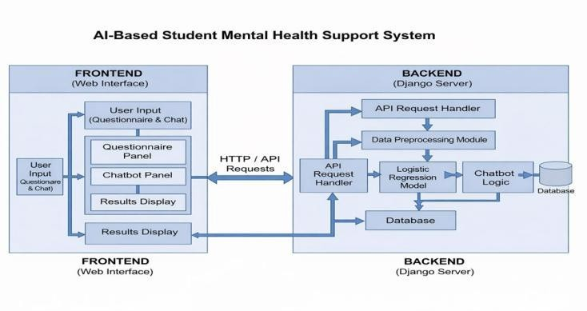
Fig. 1. Step-by-Step Process Flow

AI-Based Risk Assessment Engine
The brain of this setup lives right here: running logistic regression alongside hand-coded rules, it checks for signs like levels of stress, anxious thoughts, emotional state, and how well someone sleeps. Using that data, learners get placed into one of three groups: low, moderate, or high risk for mental health struggles.

Rule-Based Decision Logic
In order to make transparent and explainable decisions, the system. It combines rule-based conditions with machine learning. These rules identify thresholds and symptom patterns that then help justify why a student was placed into a particular risk category.

Chatbot and Recommendation Module
According to the risk assessment result, it will provide personalized feedback, suggestions for self-help, and supportive messages through a chatbot module. This module will help students learn about their mental health status and guide them toward positive actions.

Database Layer
The database keeps all the student information, test scores, and interactions with the chatbots. It also keeps a record of changes, which enables the tracking of mental health changes over a period of time.
With this safely locked away within the system, all the student information is secured, from test scores to interactions with the chatbots, personal data, etc. Week after week, the records add up, providing a consistent trend of moods and actions. Behaviors start to take a rhythm, observed carefully but only after a prolonged period, rather than jumping to conclusions after a brief period of observation being over.

Admin Dashboard
The Admin Dashboard Module gives authorized administrators access to a single interface from where they can monitor/intervene with regard to the mental health assessment system. Administrators can, from this single interface, observe student risk distribution, trends for student assessment over time, system stat concerns, and overall system health. This helps institutions derive appropriate insights into the mental health of their students, identify critical cases at an early stage, and subsequently inform decisions concerning appropriate support strategies.

System Architecture and
Design Methodologies

The robustness and efficacy of the proposed AI-Based Student Mental Health Assessment and Early Risk Detection System can be ensured by a layered and modular architecture and by iteratively employing modular system methodologies. The robustness will also help maintain data security and transparency.

A.Architectural Overview
The system is designed based on a logical separation of user interactions, application processing, and system data by implementing a multi-tier architecture, which makes it scalable, easy to maintain, and enhances application development.
- Presentation Layer – The Presentation Layer shall act as a direct interface between the students, administrators, and the system. The Presentation Layer shall be a safe web-based application with browsers as clients. The interface will be used by the student to carry out mental health questionnaires, converse with the AI chatbot, and view their mental health risk levels and personalised recommendations. Administrators may access a specific dashboard to observe trends for students, statistics for

assessments, and system use statistics. The layer is optimised for speed with the goal of creating a fluid response to imperative changes within the system. This is for user convenience and low response time to ensure a smooth and non-intrusive user experience. The input data, assessment requests, and user authentication data are securely sent to the backend by implementing HTTPS- based REST APIs.
- Application Layer - The Application Layer acts as the core processing unit of the entire system and has been realized using a Django-based RESTful framework. This manages user sessions, receives incoming requests, and runs the major analysis workflows. This includes the AI- based mental health assessment engine that takes the preprocessed data from the questionnaires and applies the Logistic Regression model combined with rule-based decision logic to arrive at the student's risk level for their mental health. The Application Layer also controls chatbot response generation, personalized feedback delivery, and the admin data aggregation process. In addition, this layer guarantees that all processing is made transparent, explainable, and in accordance with generally accepted ethical principles underlying mental health assessment.

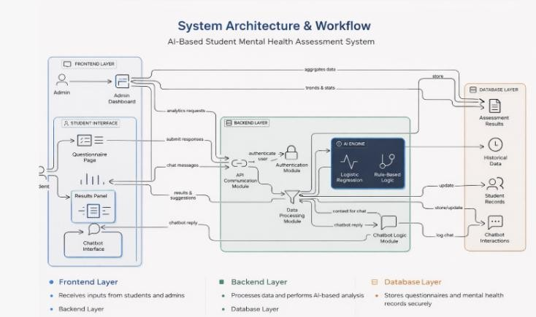
- Data Layer - This layer will be responsible for persisting, maintaining integrity, and analysing historical data. The storage in the secure database includes students' profiles, questionnaire responses, risk classification results, and logs from chatbot interactions. The longitudinal monitoring would be made possible since this layer keeps a record and history of the profile, thus enabling this system to show mental changes over time. Strong security mechanisms like encrypted storage, role-based access control, and secure session handles are used to safeguard sensitive mental health information and to maintain the required standard on privacy.
A module is then easily updated, tested, or even replaced without affecting the whole system. This permits continuous improvements in AI models and assessment logic.
- Agile Development – For implementing the Agile method of development, an Agile development methodology will be followed. This method involves performing development iterations, and due to this fact, continuous testing and evaluation can result in appropriate assessment rules being designed, and the accuracy of the Artificial Intelligence model can also be enhanced. The user experience will also be enhanced. The machine learning models can the agile process helps accommodate rapid response to shifting student mental health states and newly emerging institutional needs.

- Security-First Design – Due to the nature of mental health information, a Secure by Design approach is taken to design the system. In this, user authentication is carried out through robust authentication techniques, different user roles are provided to both students and admin users, HTTPS communication is used to ensure confidentiality, and input validation is carried out to control misuse by invalid users.

Implementation and Use Cases
This strong beginning is built during set-up, where it turns design plans into something strong that can handle any increase in safe fashion. Industry tools build each piece of it so everything runs fast while keeping information accurate in figuring out emotional well-being minute by minute.

A. Implementation Details
The smooth working of the AI-Based Student Mental Health Assessment and Early Risk Detection System can be guaranteed through a well-designed technological realization of it and its usage in real-life student or institute settings. The system is designed to transform the conceptual architecture into an entirely functional intelligent platform utilizing various web technologies, artificial intelligence applications, as well as secure cloud environments.
.

Fig. 2. Three tier architecture

- Design Methodologies

This means that system development is done using Agile and Modular Design principles in combination:

1. Modular Design: The system follows a modular architecture in which each functional component operates independently. Various modules comprising questionnaire processing, AI risk evaluation, chatbot interaction, database management, and admin analytics are designed with high internal cohesion has to be high with low external coupling.
- Frontend (Web Interface) - Frontend is used as a primary interface for both students and admin. Students can access the questionnaire page, results interface, and chatbot interface, where they can respond and get mental health-related feedbacks, etc. Administrators can access the admin interface where they can view stats, risk, etc. Frontend communicates with the backend via secure http/rest apis, allowing real-time data transfer between them..

- Backend (Django Framework) - The back-end is built with the Django web framework, managing the system's logic, user authentication, data validation, and API communication. Django performs all frontend requests, processes student responses, and relays data to the AI engine. Besides this, it also manages the storing of data, user sessions, and admin-level access to reports and analytics.

- API Communication Module - A separate API Request Handler handles the communication between the front and back ends. It receives responses of the questionnaires, messages from the chatbot, and requests for analytics. These requests come from both the user and the administrator; through this, such requests are channeled via the module for data processing and an AI engine in a secure way to allow structured and reliable data flow.

- Data Processing Module - This module will clean, normalize, and format the students' responses before feeding them into the AI engine. Meaningful features to be extracted include stress level, mood, academic pressure, sleep patterns, and emotional indicators, making raw questionnaire data useful as structured inputs for the model's prediction stage.

- AI Engine (Logistic Regression + Rule-Based Logic) - The core intelligence of the system is provided by a combination of a Logistic Regression model and a Rule-Based Decision Logic Model. The Logistic Regression model predicts the probability of mental health risks in response to student replies. The Rule-Based logic is integral to deciding psychological thresholds and expert-defined conditions to further categorise the classification of risk based on levels of low, moderate, or high risk. Such a mixed approach would ensure improvement in both precision and interpretability.

- Chatbot Logic Module - The Chatbot Module provides interactive emotional support. The Chatbot will use a combination of predefined psychological rules and AI-based context to find the meaning to produce responses. The AI engine feeds contextual data into the chatbot, offering it to users for emotional guidance, stress management tips, and supportive feedback. All interactions are logged for further analysis.

- Database Layer - Within the database layer, all the student-related data, including the responses to the questionnaire, the mental health risk scores, the historical records of the student assessment, and the student interactions with the chatbots, is stored in the form of a data pool, which then enables the constant observation of the student mental health behavior patterns. This system also supports accurate trend analysis, risk identification, and enhanced decision- making, both in AI engines and administrators.

- Admin Dashboard Module - The dashboard provides authorized personnel within each institution with a complete picture of the entire system. The system will present complete information on numerous student mental health risks, assessments, interventions, trends, system usage statistics, and platform health indicators. With this type of dashboard, administrators can easily recognize high-risk student groups, monitor the changes in mental health trends, and ensure proper utilization of the system functioning
effectively, thus facilitating timely intervention and the management of mental healthcare.

Supporting Technologies and Deployment

  - Data Collection (Questionnaires & Chatbot Inputs)

The Data Collection and Preprocessing Module is designed to gather student data on mental health using structured questionnaires. The questionnaire is used to gather student data on various psychological parameters, including the state of stress, academic stress, mood swings, sleep, and feelings. Additionally, data is collected from the chatbot, where various inputs serve to evaluate student emotional health.

Deployment Integration

This system uses a web-based server environment that allows for scalability, consistency, and ubiquitous availability. It uses a secure cloud environment for a Django backend/server & database. The system is able to accommodate multiple users at a given time.

Use Cases
  - Real-Time Mental Health Risk Detection:
When a student completes a questionnaire or chats with the chatbot, the AI engine quickly evaluates the data received, calculating a student’s risk score regarding their mental health. The AI system thus categorizes a student’s risk level into low, moderate, and high risk, giving immediate results, thus enabling early awareness and support.

Automated Escalation for Enforcement:
The system will integrate an automated mechanism that will aggregate different verified reports on scams, evidentiary data, (domain info, server IP). This evidence bundle is quickly sent to the pre-arranged cybercrime authorities and host providers for domain suspension.

Early Warning and Intervention Support:
If the student is identified to require high levels of mental health attention, the system flags the student as requiring greater attention, highlighting the suggestions as guidance with a self-help element.

Continuous Student Monitoring:
All the assessment data is stored in the database. Hence, it is easy to track any changes. This is essential in tracking the trends in the student's mental health to notice any signs of stress build-up over prolonged periods.

System Performance and Security Monitoring:
The backend will continuously monitor the activity, system, and user behavior to detect any abnormalities or issues, which are then recorded to ensure data security, platform reliability, and availability.

Security and Privacy
Security and Privacy
The Intelligent Student Mental Health Monitoring System is developed with adequate security features regarding privacy, confidentiality, etc, over personal student data. The system is actually designed for handling confidential data regarding emotional conditions, stress about student health. Student data is confidential, so confidentiality, integrity and ethical handling is a primary requirement.

Data Privacy Protection
All the student data collected through questionnaires and chatbot interactions is highly confidential in nature. Any data in the form of names, emails, or student registration numbers is kept highly secure and is not mixed with mental health data wherever feasible. Only authorized users, such as administrators or counselors, are allowed to see sensitive information through role-related functionality authentication.

Secure user authentication
The system also has different kinds of login systems in place, which can be used by students and administrators alike. The password is encrypted before entering it into the database. No unauthorized persons can perform functions on their own by entering the database, which contains information encrypted in this way. The system will enable students to only view their own results, while administrators can view aggregated statistics on mental health.

Encrypted Data Transmission
Every data exchange or communication that occurs in both directions in the front end/user interface and back end/Django server utilizes only HTTPS communication channels. This helps in avoiding eavesdropping or hacking in communication with other users.

Secure Data Storage
The database is also protected from unauthorized access, unauthorized modifications, and data loss using access control, encryption, and backups. The mental health data is stored in a structured and protected way, so that unauthorized system services cannot access that data.

Ethical Usage of AI and Student Consent
It is operated on ethical principles of artificial intelligence. Students understand their data is being utilized solely for data processing in mental health evaluation and other well- being factors in an institution setting. Medical decision- making is not conducted by the model since predictions are solely risk-based intervention.

System Monitoring and Protection
The backend continually observes login requests, API requests, data accesses, etc. It also logs all abnormal behaviors that may pose a potential security threat to a system.

Performance and Limitations
The performance of the Intelligent Student Mental Health Monitoring System proves to be very robust in real-time emotional assessment, early risk detection, and institutional-level mental health insights; nonetheless, the pitfalls that it carries, as with all AI-driven systems, need to be acknowledged.

System performance
It efficiently processes the student inputs, such as responses to questionnaires or interactions with a chatbot, via the backend server to ensure the least response time. A lightweight, scalable web framework allows multiple users to use this platform without significant performance degradation. It also provides an Admin dashboard displaying real-time student risk levels, usage trends, and overall system statistics..

Model Effectiveness
The machine learning model can identify common mental health patterns based on information provided by a series of questions and conversations. The model performs well in identifying students who may be at moderate or high risks. This will help address any issues arising, as more data are added with each passing time, increasing prediction accuracy for the model.

2) Limitations
Despite its high efficacy, the system has a number of shortcomings. To begin with, the AI model is significantly influenced by the information provided by students, which is assumed to be accurate and true, though it is difficult to rely on such assumptions perfectly. Second, it is important to note that the system is not a substitute for any kind of therapy, though it can be used in the decision-making process.

Result and Discussion
The proposed Intelligent AI-Driven Student Mental Health Assessment System has also been validated by simulating the self-assessment data of the student, which might relate to various mental health conditions such as stress, anxiety, and depression. The Intelligent System has analyzed the answers provided by the users and classified the self- assessments into various levels of risks such as low-risk, medium-risk, and high-risk conditions. Moreover, the Intelligent System has identified the signs of mental conditions such as emotional problems, sleeping issues, lack of motivation, etc.
Further, the interaction with the Intelligent System has offered instant feedback to the student. In the feedback message, the student is presented with his/her mental health conditions and the appropriate self-care suggestions. In the same context, the Admin received real-time statistics such as the number of high-risk conditions, the overall risks, and student assessment trends.
During various interactions made by the users with the system, it exhibits stability; data are saved for further analysis and monitoring. The results confirm the fact that by the use of the system, early-stage mental health risk can be identified, and thus, prompt intervention be provided.

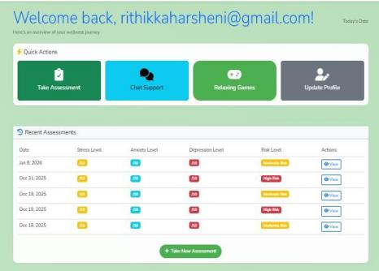
Fig. 1. Dashboard
- T. NGUYEN, D. PHUNG, AND S. VENKATESH, “DEEP LEARNING FOR MENTAL HEALTH DIAGNOSIS,” ACM COMPUTING SURVEYS, VOL. 54, NO. 6, PP. 1–36, 2021.

- R. B. PATEL AND K. MEHTA, “SECURITY AND PRIVACY IN HEALTHCARE INFORMATION SYSTEMS,” JOURNAL OF CYBERSECURITY IN HEALTHCARE, VOL. 5, NO. 1, PP. 40–52, 2022.

- M. CHEN, Y. HAO, K. HWANG, AND L. WANG, “DISEASE PREDICTION USING MACHINE LEARNING IN HEALTHCARE,” IEEE ACCESS, VOL. 5, PP. 8869–8879, 2017.

- S. KAUR AND R. SINGH, “RULE-BASED EXPERT SYSTEMS FOR MENTAL DISORDER DETECTION,” INTERNATIONAL JOURNAL OF COMPUTER APPLICATIONS, VOL. 178, NO. 10, PP. 28–35, 2019.

- A. ALHASSAN ET AL., “AI-BASED EMOTION AND STRESS DETECTION,” SENSORS, VOL. 21, NO. 14, PP. 1–
19, 2021.

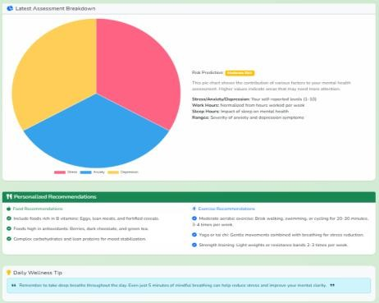
Fig. 2. Pie chart

CONCLUSION
This paper proposed a special Intelligent AI-Driven System for Student Mental Health Assessment and Early Risk Detection that would be supportive for proactive mental healthcare in an academic environment. The proposed system analyzes the student self-assessment data through AI and rule-based decision logic to identify early signs of stress, anxiety, and depression. The system helps the students to be more aware of their mental health conditions to seek timely support through real-time feedback, personalized recommendations, and continuous monitoring. In summary, the proposed solution bridges the gap between mental health awareness and early risk detection by integrating artificial intelligence into digital health care delivery.

References

- WORLD HEALTH ORGANIZATION, MENTAL HEALTH IN YOUNG PEOPLE, WHO PRESS, GENEVA, 2023.

- S. KUMAR AND R. SHARMA, “ARTIFICIAL INTELLIGENCE IN MENTAL HEALTH CARE: APPLICATIONS AND CHALLENGES,” IEEE ACCESS, VOL. 10, PP. 45612–45625, 2022.

- J. SMITH AND L. BROWN, “WEB-BASED MENTAL HEALTH ASSESSMENT SYSTEMS FOR STUDENTS,” JOURNAL OF DIGITAL HEALTH, VOL. 9, NO. 2, PP. 65–78, 2021.

- A. PATEL, M. VERMA, AND P. SINGH, “MACHINE LEARNING APPROACHES FOR DEPRESSION DETECTION,” INTERNATIONAL JOURNAL OF HEALTHCARE INFORMATICS, VOL. 14, NO. 3, PP. 120–
132, 2021.

